Requisition Form

- Authors Information
Sr. No | Name | Address | Pin code | Nationality | Date Of Dispatch
1 | Shubham Kumbhar | DR.D.Y. PATIL INSTITUTE OF TECHNOLOGY, PIMPRI | 411018 | Indian
2 | Devdatt Khilari | DR.D.Y. PATIL INSTITUTE OF TECHNOLOGY, PIMPRI | 411018 | Indian
3 | Atharva Athanikar | DR.D.Y. PATIL INSTITUTE OF TECHNOLOGY, PIMPRI | 411018 | Indian
4 | Sahil Borkar | DR.D.Y. PATIL INSTITUTE OF TECHNOLOGY, PIMPRI | 411018 | Indian

- Applicants Information
Sr. No | Name | Communication Address | Pin code | Nationality | Phone No
1 | Shubham Kumbhar | DR.D.Y. PATIL INSTITUTE OF TECHNOLOGY, PIMPRI | 411018 | Indian | 7058574276
2 | Devdatt Khilari | DR.D.Y. PATIL INSTITUTE OF TECHNOLOGY, PIMPRI | 411018 | Indian | 7249189872
3 | Atharva Athanikar | DR.D.Y. PATIL INSTITUTE OF TECHNOLOGY, PIMPRI | 411018 | Indian | 7796678222
4 | Sahil Borkar | DR.D.Y. PATIL INSTITUTE OF TECHNOLOGY, PIMPRI | 411018 | Indian | 7666822033

- Category of Applicant: (Please Tick (X) for correct answer)
Individual | Business | Others
X

- Applicant Signature (Signature File type- i) jpg and jpeg format. ii) File size Less than 512 KB

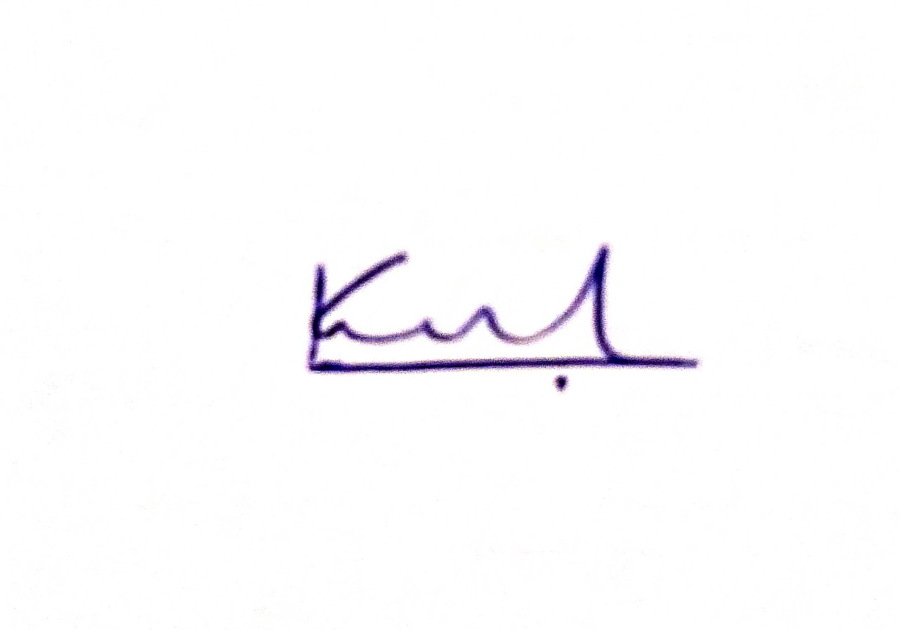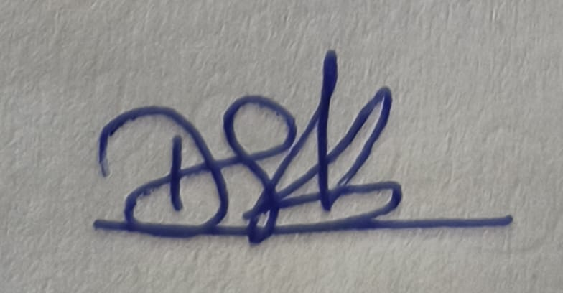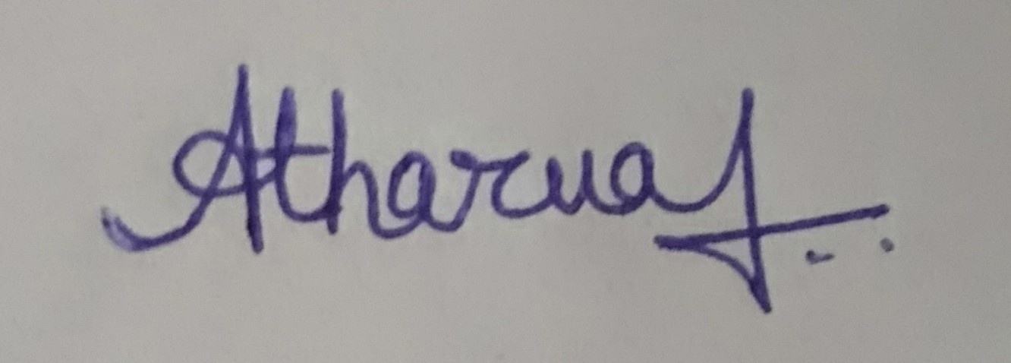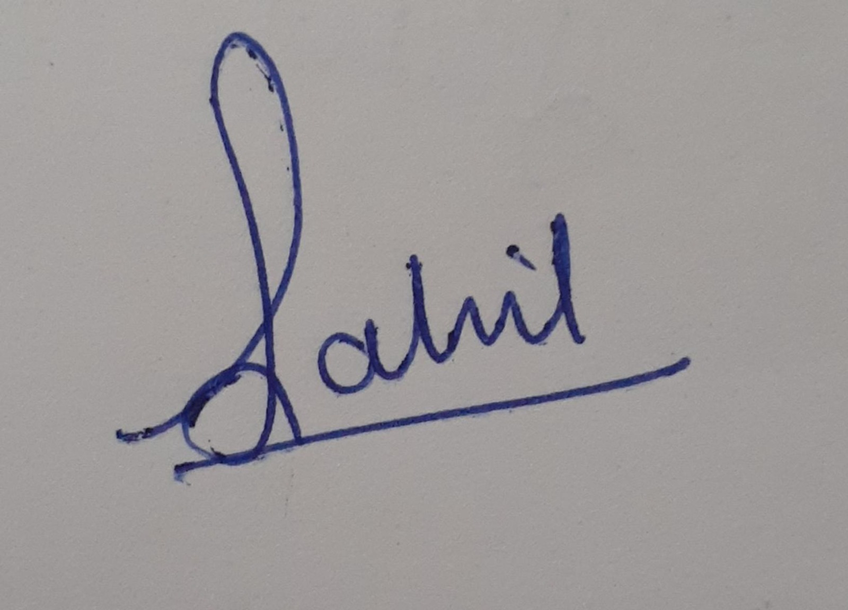

- Nature of the applicant's interest in the copyright of the work (Please Tick (X) for correct answer)
Author | Owner | Publisher | Composer | Producer | Artist
 | X

- Class of the work (Please Tick (X) for correct answer)
Literacy/Dramatic | Artistic | Cinematograph Film | Sound Recording | Music | Computer Software
 |  |  |  |  | X (VS Code, JS Frameworks, ML)

- Description of the work (In 200 Characters):
Kisan Mitra is an AI-driven platform revolutionizing agriculture through soil analysis, crop recommendations, and early disease detection. It promotes sustainable practices like crop rotation and reduced tillage, enhancing soil health and biodiversity. By providing educational resources, it empowers farmers to optimize yields and profitability while ensuring environmental sustainability.

- Title of the Work:
“Kisan Mitra: Transforming Agriculture with Next-Gen Disease Detection and Prediction.”

- Language of the Work: English

- Whether work is Published or unpublished? (Please Tick (X) for correct answer)
Published | Unpublished
 | X

- For Published Work

11A. Year and country of first publication and name, address and nationality of the publisher

Sr. No | Name | Address | Pin code | Nationality | Country | Year of Publish
11B. Years and countries of subsequent publication, if any, and names, addresses and nationalities of the publishers.

Sr. No | Name | Address | Pin code | Nationality | Country | Year of subsequent Publish

11C. Names and addresses and nationalities of the owners of the various rights comprising the copyright in the work and the extent of rights held by each, together with particulars of assignments and licenses, if any. Names and addresses and nationalities of other persons, if any authorized to assign or license the rights comprising the copyright.

Sr. No | Name | Address | Pin code | Nationality | Country | Year of subsequent Publish

- Is the work to be registered:

(a) an original work? | Yes
(b) a translation of a work in public domain? | NO
(c) a translation of a work in which copyright subsists? | NO
(d) an adaptation of a work in the public domain? | NO
(e) an adaptation of a work in which copyright subsists? | NO

- If the work is a translation or adaptation of a work in which copyright subsists:
- Title of the original work
- Language of the original work
- Name, address, and nationality of the author of the original work and if the author is deceased, the date of his decease.
Sr. No | Name | Address | Nationality | Country | Date of decease

- Name, address, and nationality of the publisher, if any, of the original work.
Sr. No | Name | Address | Nationality | Country

(e) Particulars of the authorization for a translation or adaptation including the name, address, and nationality of the party authorizing.
Sr. No | Name | Address | Nationality | Country

- Document for Upload:
- Your Literature (in. dox/.doc format).
Mail as separate file.
- If the work is published by a person other than the applicant, a No Objection Certificate in original may be obtained from the person/firm and enclose with the application.
- Please intimate the Name, address & Nationality of the person whose photograph appears on the work. If that person is other than the applicant, a No Objection Certificate, in original may be obtained from the person or from his legal heir(s) if the person is deceased or from the guardian if the applicant is minor and the same may be enclosed with the application.

Declaration applicants:
I/We all the applicants are hereby declare that, the information provided by us in this requisition form to research drafting team is true and not copied from anywhere. If this is so, it is our sole responsibility. In such cases Research Drafting Team do not responsible for any legal action.

Names and Signatures of applicants:

Shubham Kumbhar Devdatt Khilari Atharva Athanikar Sahil Borkar

Date:

Place: Pimpri

